Optimization result reporting:

**Dynamic Increasing of Low Mutation Ratio/Decreasing of High Crossover Ratio (ILM/DHC)** was found to be more effective with smaller populations (25 and 50 individuals), where higher mutation rates later in the search process introduced necessary diversity, helping the algorithm avoid local optima. **Dynamic Decreasing of High Mutation Ratio/Increasing of Low Crossover Ratio (DHM/ILC)** performed better with larger populations (200 and 400 individuals), where a higher crossover rate towards the end of the search allowed for the generation of stronger offspring, leveraging the diversity already present in the population [1].

The concept of dynamic crossover and mutation probability, helps the optimizer to perform xhigh exploration in earlier generation and and high exploitation later on, which would result in high diversity exploration in earlier phase and leads to optimal solution.

• **Mutation:** Introduces diversity by altering genes randomly in individuals, helping avoid premature convergence to suboptimal solutions.

• **Mutation**:

* Introduces random changes to individuals, allowing the algorithm to explore new regions of the search space.
* Helps in **exploration** by introducing diversity.
* Typically, a **mutation probability (Pm)** between **0.01–0.1** is used.

• **Crossover:** Combines features of parent solutions to create offspring, aiding in exploiting good solutions.

• **Crossover**:

* Combines the genetic material of two parent solutions to generate offspring.
* Helps in **exploitation** of the search space by combining existing good solutions.
* Usually, a **crossover probability (Pc)** of **0.6–0.9** is set.

***Starts with a high mutation rate (100%) and low crossover rate (0%). As the algorithm progresses, the mutation rate decreases, and the crossover rate increases linearly. By the end of the search, mutation is 0%, and crossover is 100%. Best suited for small populations where diversity is crucial early in the search process.***

***Starts with a low mutation rate and high crossover rate, the opposite of DHM/ILC. Mutation increases while crossover decreases as the search progresses. Works well with larger populations where diversity is naturally present, and focus shifts to exploiting existing solutions.***

**Dynamic crossover and mutation rates can be adjusted using linear functions over the number of generations:**

**Mutation rate, MR = LG/Gn, where LG is the current generation level nd Gn is the total number of generation**

**Crossover rate, CR = 1 – LG/Gn**

**This concept will avoid local optima, and helps in efficient search**

***Example for selection of mutationa and crossover weight value:***

*The values of mutation and crossover rates are calculated according to the generation level number. If the generation level is 500, the maximum generation is*=1600*, and the population size is*=100*, then the value of mutation and crossover rates according to the previous equations are:*

𝐿𝐺=500

𝐺𝑛=1600

𝑀𝑅=1−(500/1600)=0.69

𝑀=0.69∗100=69*individuals are to be mutated in generation level 500.*

*For Crossover rate:*𝐿𝐺=500,𝐺𝑛=1600*,*𝐶𝑅=(500/1600)=0.31

𝐶=0.31∗100=31*individual are to be used for the crossover process at generation level 500.*

Computing infrastructure used: Google colab T4 GPU

**Half Aperture Angle for SAR**

The angular dispersion of the radar beam with respect to its central axis is defined by a SAR sensor's half aperture angle. It has effects on swath width, resolution and signal strength. The radar may cover a greater area with each pass if the half aperture angle is wider because it widens the swath width, or the amount of ground the radar covers. It may, however, weaken the signal and diminish resolution.{Matar, 2023 #77}.

The swath width can be calculated using the altitude HHH of the satellite and the half aperture angle θ.

W = 2 H * tan(θ)

Where,

H is the altitude of the satellite (in km),

θ is the half aperture angle (in radians).

**Thus when** θ = 25 degree, swath width will be approximately 585km, and when θ = 1.5 degree, swath will be approx. 32 km

This having big half aperture angle results in larger swath width, larger coverage with poor resolution.

**Earth Model we choose:**

The WGS 84 datum surface is an [oblate spheroid](https://en.wikipedia.org/wiki/Oblate_spheroid) with equatorial radius *a* = 6378137 m at the equator and [flattening](https://en.wikipedia.org/wiki/Flattening) *f* = 1⁄298.257223563. The refined value of the WGS 84 [gravitational constant](https://en.wikipedia.org/wiki/Standard_gravitational_parameter) (mass of Earth's atmosphere included) is *GM* = 3.986004418×1014 m3/s2. The angular velocity of the Earth is defined to be *ω* = 72.92115×10−6 rad/s [2].

Our objective:

1. Minimize revisit time O_1(x)
2. Maximize dwell time O_2(x)

In **multi-objective optimization**, we need to minimize both objectives. However, since were trying to **maximize** the dwell time, we need to **transform** this into a **minimization** problem.

Mathematically,

* **Minimizing** O_1(x): We want to minimize the revisit time directly.
* **Maximzing O-2(x): We want to maximize the dwell time. However, since DEAP’s optimizer minimizes by default, we must transform this into a minimization problem. To do that, we minimize the negative of dwell time:**

O_2(x)_maximizing = maximize O_2(x). # dwell time

= minimize - O_2(x)

The weights define whether to minimize or maximize an objective. (w1, w2) = (-1.0, -1.0) represents the fitness function as,

Fitness(x) = w1 * O_1(x) + w2 * O_2(x)

= -O_1(x) + O_2(x)

minimizing the fitness, results in minimization of revisit time and minimization of -ve of dwell time.

**Test1: NSGA3 optimizer, for best fit inclination angle and RAAN angle for the constellation of 3 plane and 4 satellite in each plane**

Number of objectives = 2, maximum cumulative dwell time and minimum cumulative revisit time of constellation

Fitness / evaluation function = -1 * cumulative revisit time (CRT) -1 * ( - cumulative dwell time (CDT))

Optimizing parameter = Inclination (i), and RAAN

Population size = 20,

NGen = 15

Number of plane = 3

Number of satellite per plane = 4

Fitness weight = (-1, -1)

Crossover weight = 0.7

Mutation weight = 0.2

**Result of Test 1:**

Figure1: final population fitness nsga3-20P15G

Best 5th individual (inclinations, raan) for each plane:

[[21.711890082943626, 84.1511867209388, 15.255350281208214], [168.27944861745772, 288.7786064367185, 223.71299670259702]]

Best fitness cumulative revisit time 75060.0 seconds and cumulative dwell time 9750.0 seconds

Fig : Pareto front of NSGA-III

Fig : resulted constellation of optimized using NSGA3 for 3plane 4 satellite per plane, constellation where genetic algorithms applied with population size 20 for 15 generation

Analysing the earlier batch experiment, We can expect the right plane to detect the area of our interest within the range as for inclination angle ranges from 0 to 90, and for RAAN angle ranges from 100 to 250 degrees.

## Experiment 1:

**NSGA3 optimizer, where mutation and crossover probability keep changing dynamically. In this experiment we apply Mu Comma Lambda ( $μ,χ)$ [2] concept. Where the next generation population is selected from only the offspring. The population sizes is also decrease by 5% per generation, to the minimum value of 20 to reduce computing cost and time**

|  |  |  |  |  |  |
| --- | --- | --- | --- | --- | --- |
| **Pop_size (n)** | **nGen** | **Pop_decrease_rate** | **crossover probability** | **mutation probability** | **Sensor half aperture angle (degree)** |
| 50 | 40 | 5% | 0.7 $↓$ | 0.2 $↑$ upto 0.4 | 25 |

**Outcome:**

The pareto front of NSGA3 suggested the final fitness solution inclinations angle and RAAN angle for 3 orbital planes as below:

|  |  |  |  |
| --- | --- | --- | --- |
| **Inclinations (i) (degrees)** | **RAANs (degrees)** | **Min Cum revisit time (seconds)** | **Max Cum dwell time (seconds)** |
| P1:99.3410,  P2:121.762,  P3: 110.121 | P1:189.109,  P2:185.229,  P3:193.289 | 48790.0 (13.5 hrs) | 3280.0 (0.9 hrs) |

**Figure 1: fitness values of cumulative revisit and dwell time of selected top 10 best individuals per generation**

As the next generation is totally depends on offspring, which cause the loss of high fitness and converges towards premature solution. Too much reliance on crossover lead to premature convergence [3]

**Test2: NSGA3 optimizer, for best fit inclination angle and raan angle for the constellation of 3 plane and 4 satellite in each plane with less population size 50, for 20 generation. Setting the crossover and mutation probability fixed and population size constant for all generation, that gives great diversity and exploration.**

Objectives: 2, maximum cumulative dwell time and minimum cumulative revisit time

Fitness / evaluation function = -1 * cumulative revisit time (CRT) -1 * ( - cumulative dwell time (CDT))

Population size = 50,

NGen = 20

Number of plane = 3

Number of satellite per plane = 4

Fitness weight = (-1, -1)

Crossover weight = 0.7

Mutation weight = 0.2

**Result of Test 2:**

Best inclination and Raan angle for 3 planes

Inclination: [86.22229025577786, 87.01299475596664, 96.93082591770099]

Raan = [163.61694545224185, 141.80832178528414, 166.67088730999177]

Best fitness cumulative revisit time of 49320.0 seconds and cumulative dwell time of 2850.0 seconds when simulating for approximately 1 day.

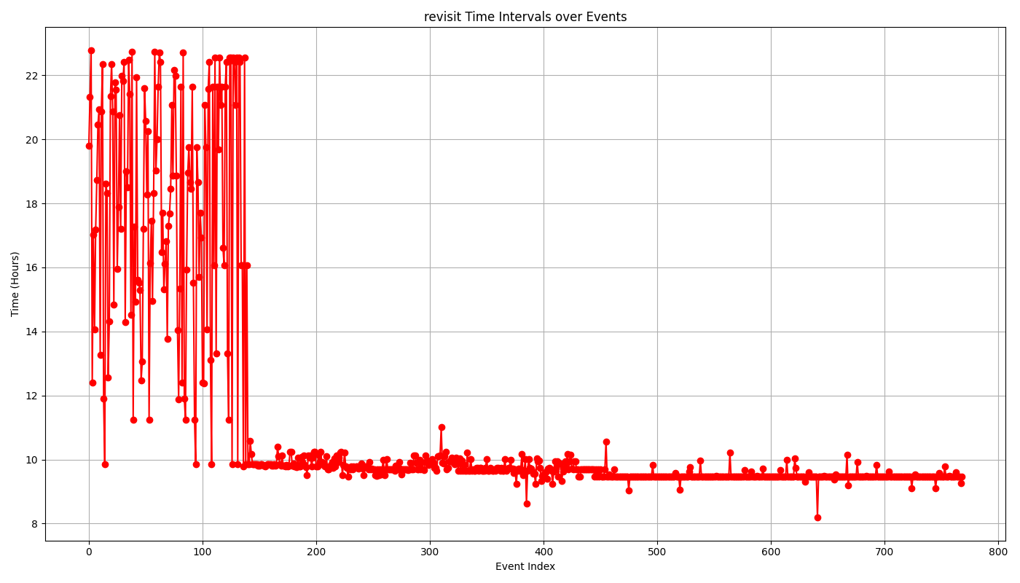

Fig. cummelative revisit time per individual in each generation

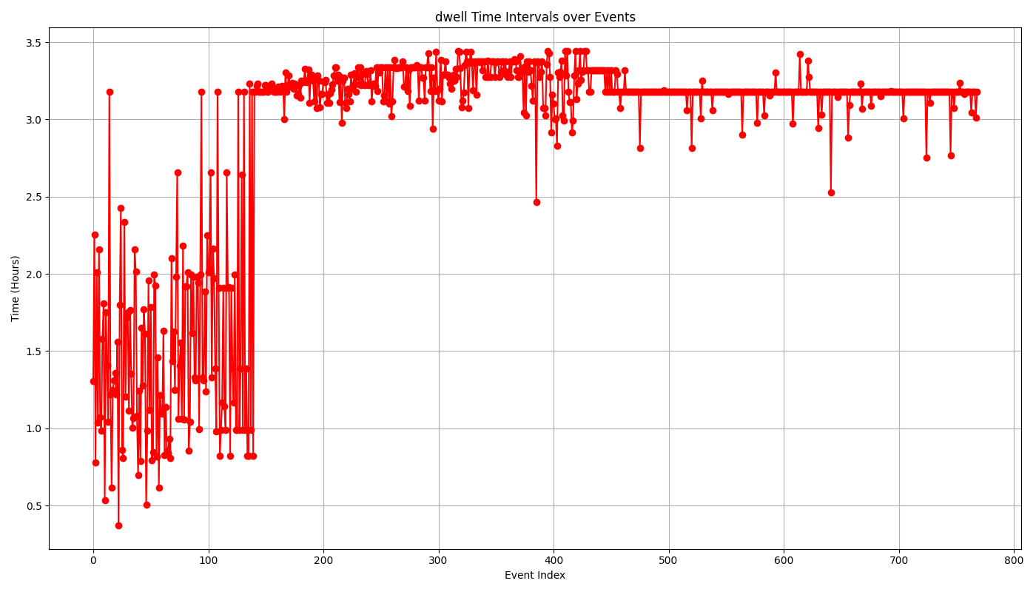

Fig. cumulative dwell time per individual in generation

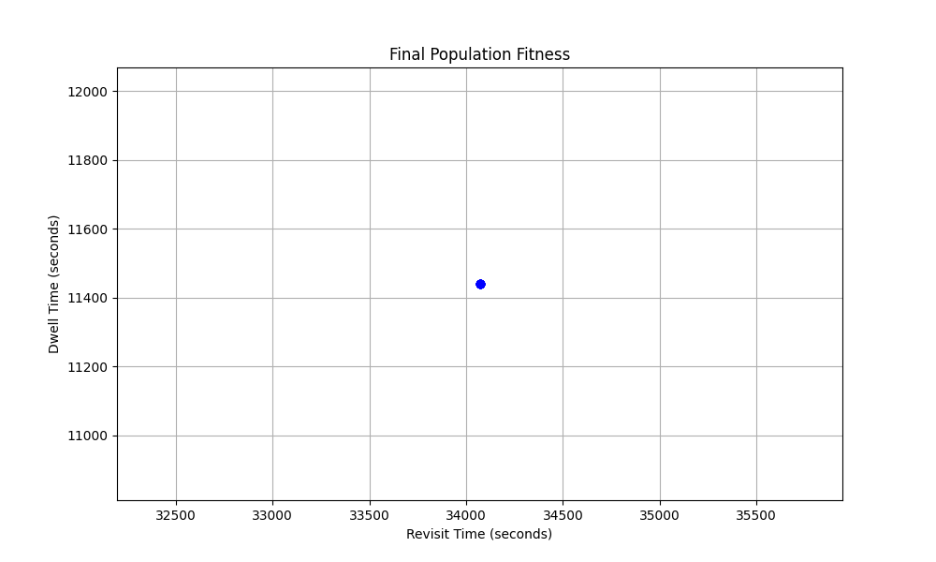

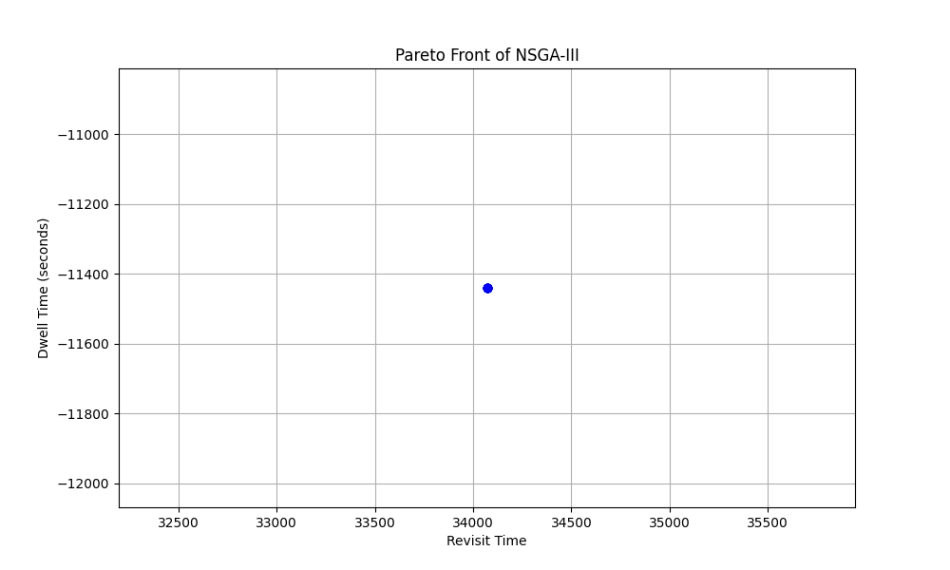

**Test3: NSGA3 optimizer, for best fit inclination angle and raan angle for the constellation of 3 plane and 4 satellite in each plane, where mutation and crossover probability keep changing as per dynamically for population of 50 with 40 generation**

**In this test We applied the eamucommalambda ($μ,λ)$ concept, where the next generation population is selected from only the offspring. The population sizes (mu) is also decrease by 5%, to the minimum value of mu per generation to reduce computing cost and time.**

Here we have the parameters that influences the update in population sizes, and number of offsprings each generation.

• initial_mu: The initial population size.

mu : The number of individuals to select for the next generation.

• min_mu: The minimum population size.

• decrease_rate: The number of individuals to decrease per generation.

• lambda_: The number of offspring generated each generation. Lambda >= mu

Parameter

Initial crossover probability = 0.7 dynamicly decreasing with genereation, allow exploration

Initial mutation probability = 0.2. dynamically increasing with generation, allow diversity

Outcome:

Best inclination and RAAN angle for 3 planes

Inclination: [99.34108805931591, 121.76238824637625, 110.12169502075129]

RAAN = [189.10910461827805, 185.22904706307273, 193.28992953380373]

Final Best fitness cumulative revisit time of 48790.0 seconds and cumulative dwell time of 3280.0 seconds when simulating for approximately 1 day.

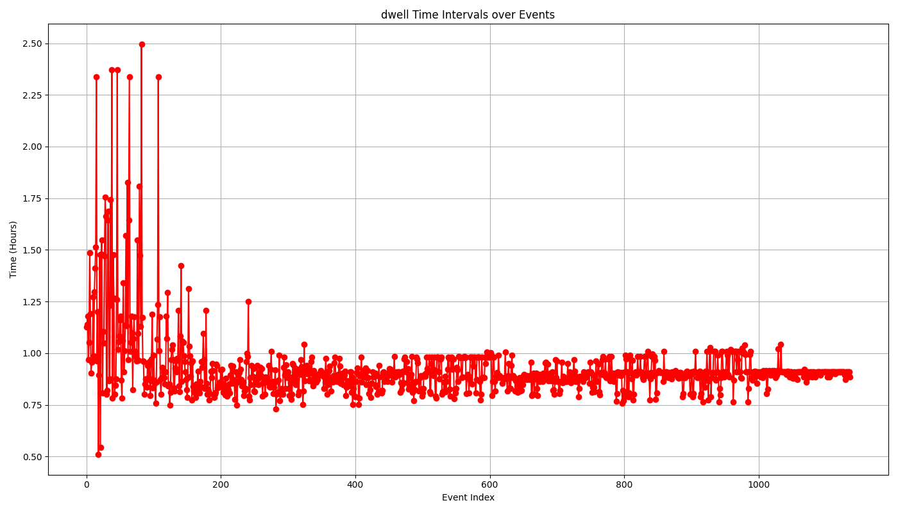

**Fig. cumulative dwell time of individual over generations**

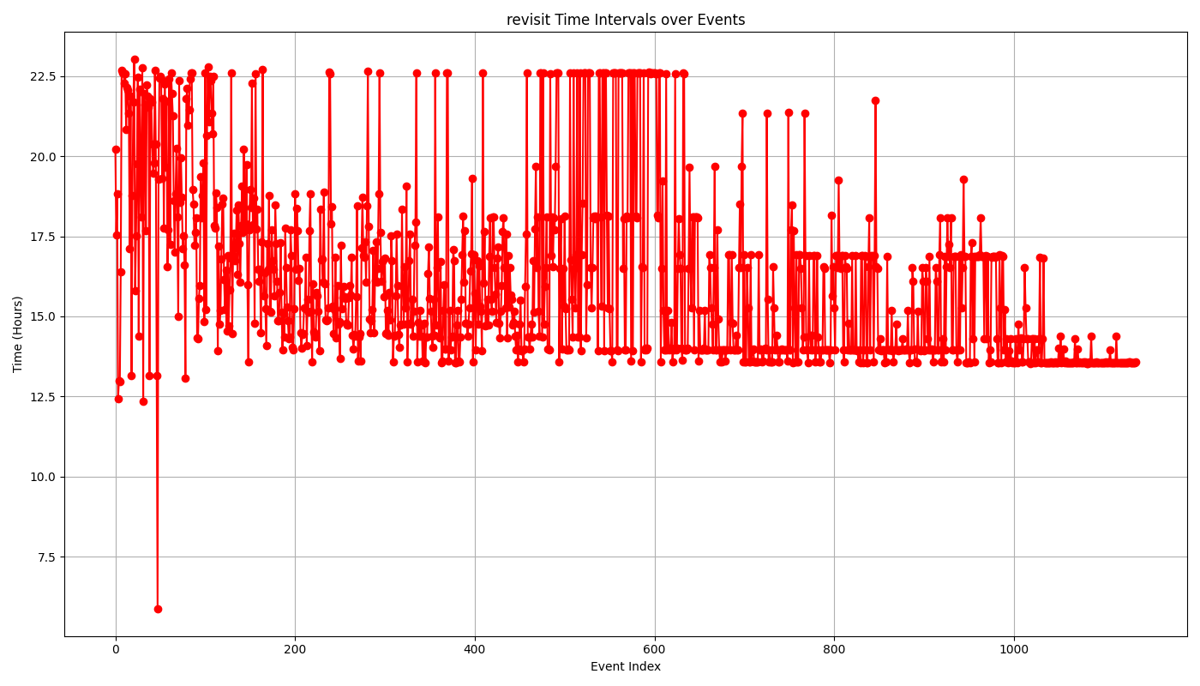

**Fig. cumulative revisit time of individual over generation**

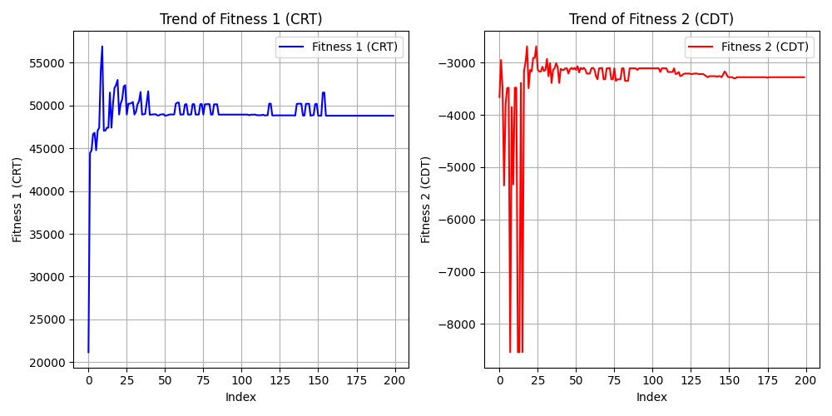

**Fig. Analysing top 5 fitness values (cum. Dwell time and revisit time) in each generation**

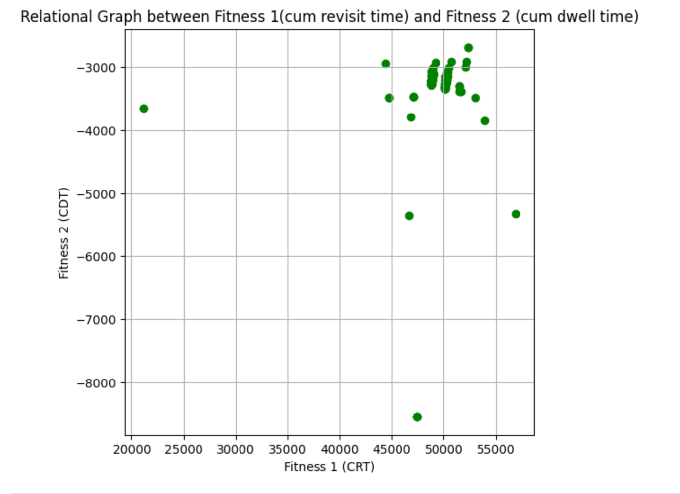

**Fig. Relational graph between top 5 best fit cum dwell time and revisit time per generation**

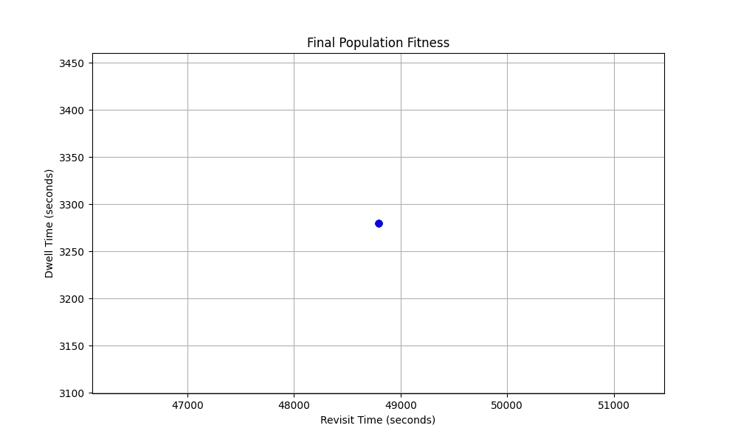

**Fig. final population fitness**

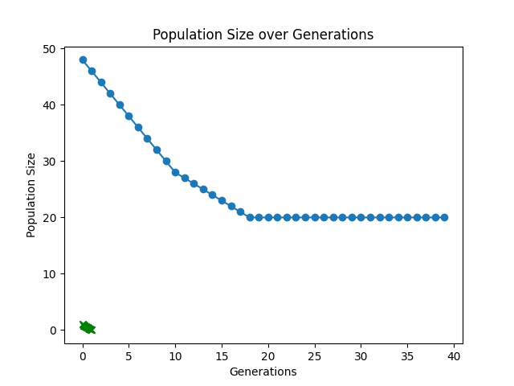

**Fig. number of population individuals per generation**

**Test4: NSGA3 Optimizer, for best fit inclination angle and rran angle for the constellation of 3 plane and 4 satellite in each plane. The test applies with eaMuPlusLambda concept, where new generation is updated from the combination of best population and offspring. The population size (mu) is kept reduced by 5% per generation, till the minimum of individual size 20 in order to reduce the computation cost and time. Starting the crossover probability high with 0.9 and keep downgrading with generation, so the algorithm explore in earlier phase. And the mutation probability initialize with 0.05 and keep increasing with generation, so the algorithm diversify later. The experiment includes the initial population of size 50 and iterated over for 40 generation.**

**Dynamic change in crossover and mutation probability**. **mathematical explanation,**

**Pc = initial_Pc * (1 – gen/nGen)**

**Pm = initial_Pm + (Pm_end – initial_Pm) * (gen / nGen)**

**Where,**

**Pc = crossover probability for current generation**

**Pm = mutation probability for current generation**

**Pc + Pm <=1.0**

**initial_Pc = start value for Pc ( in this case 0.9)**

**gen = current generation number**

**nGen = total generation (40)**

**Pm_end = maximum value for Pm ( in this case 0.3)**

**initial_Pm = minimum start value for Pm (in this case 0.05)**

**Results:**

Best inclination and RAAN angle for 3 planes

Inclination: [163.12680946440517, 144.35014536895503, 164.47562935200548]

RAAN = [2.727214567968841, 334.0645410942128, 310.26303336882825]

Final Best fitness cumulative revisit time of 29580.0 seconds and cumulative dwell time of 10760.0 seconds when simulating for 24 hours.

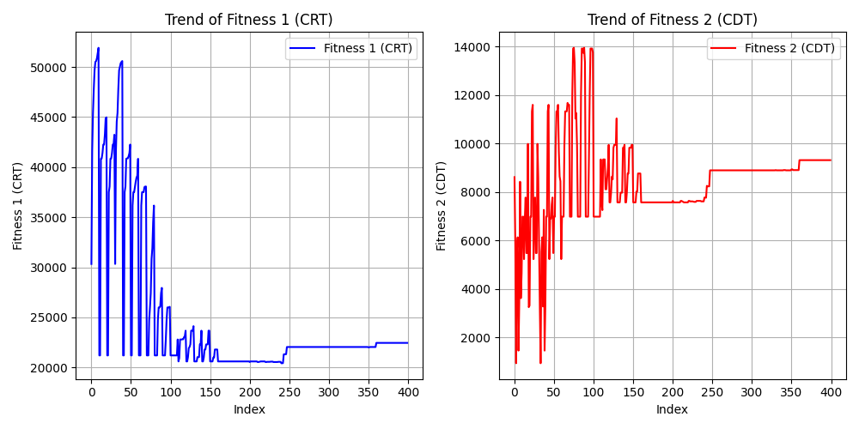

Fig. **Analysing top 5 fitness values (cum. Dwell time and revisit time) in each generation**

**Fig. relational graph between fitness values (cum dwell time and revisit time)**

**Fig. Final population fitness**

**Fig. Pareto front of NSGA-III**

**The above figure shows that, even with low population size and generation, we achieve the quite better outcome using eaMuPlusLambda algorithm, though in this test, we are stuck in local optima. In a Figure we can see that optimizer found the maximum cumulative dwell time of 14000 seconds and minimum cumulative revisit time of around 20000 seconds. As it is multi-objectives problem, and we applied equal importance to both objectives, the optimiser results with, the final best fitness individuals having cumulative dwell time and revisit time of 10760 and 29580.0 seconds.**

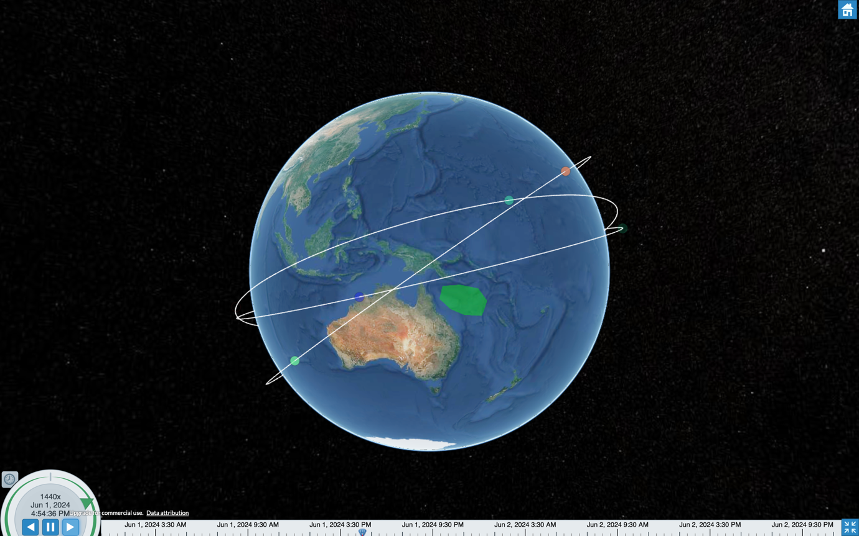

**Fig. Optimized Constellation of 3 plane 12 satellites**

**Test5: range_angle NSGA3 optimizer, inclination angles set to be within the range of 20-90 degrees, and reducing the population sizes by 1% per generation.**

|  |  |  |  |  |
| --- | --- | --- | --- | --- |
| **Pop_size (n)** | **nGen** | **Pop_decrease_rate** | **Initial_crossover probability** | **Initial_mutation probability** |
| **60** | **80** | **1%** | **0.9 $↓$** | **0.05 $↑$ upto 0.4** |

**Results outcome:**

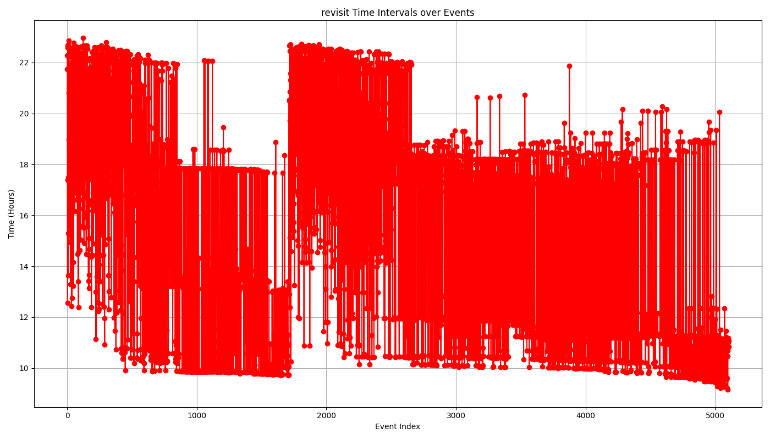

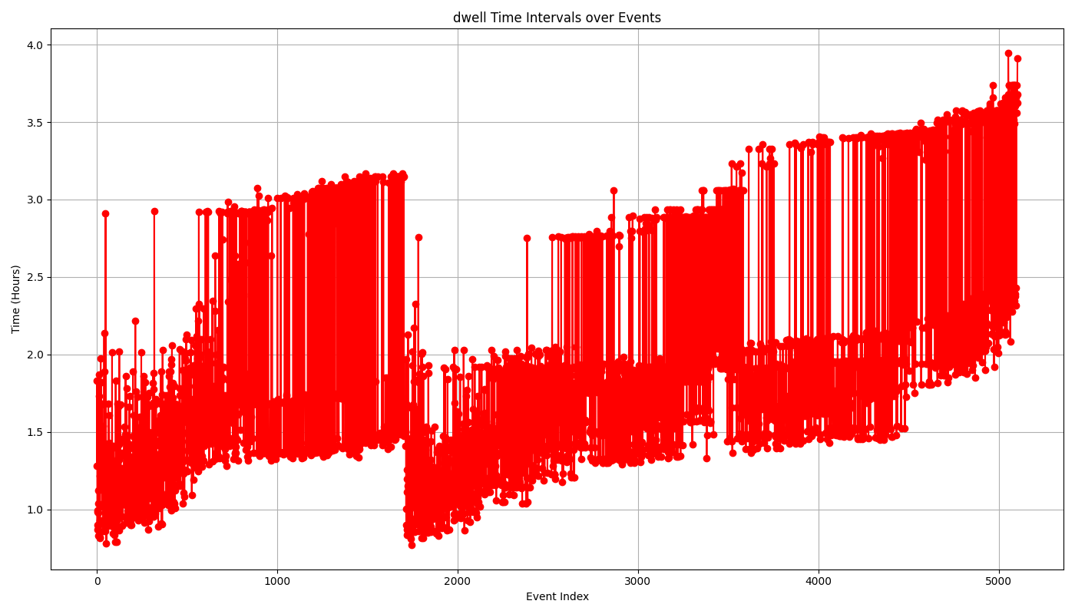

**Fig. cum revisit time of individual over generations**

**From the above plot of cum dwell time and revisit time, we can conclude that fixing the range for inclination angle 20-80, leads to the better solution with increasing cumulative dwell time and decreasing revisit time.**

**The pareto front suggest the final fitness solution as below:**

|  |  |  |  |
| --- | --- | --- | --- |
| **Inclinations_degrees** | **RAAN_degrees** | **Cum revisit time_seconds** | **Cum dwell time_seconds** |
| **[37.616, 30.202, 21.038]** | **[260.900, 237.594, 251.718]** | **33210.0** | **8560.0** |
| **[20.0,**  **20.0,**  **23.328]** | **[67.346, 336.319, 30.221]** | **38440.0** | **13180.0** |
| **[20.0,**  **20.020, 21.787]** | **[66.482, 334.983, 30.631]** | **38860.0** | **14200.0** |

**From this test, we have achieve the maximum cumulative dwell time of 14200 seconds (3.94 hours) and respective cumulative revisit time gap of 38860 (10.79 hours) seconds over a simulation period of 24 hours.**

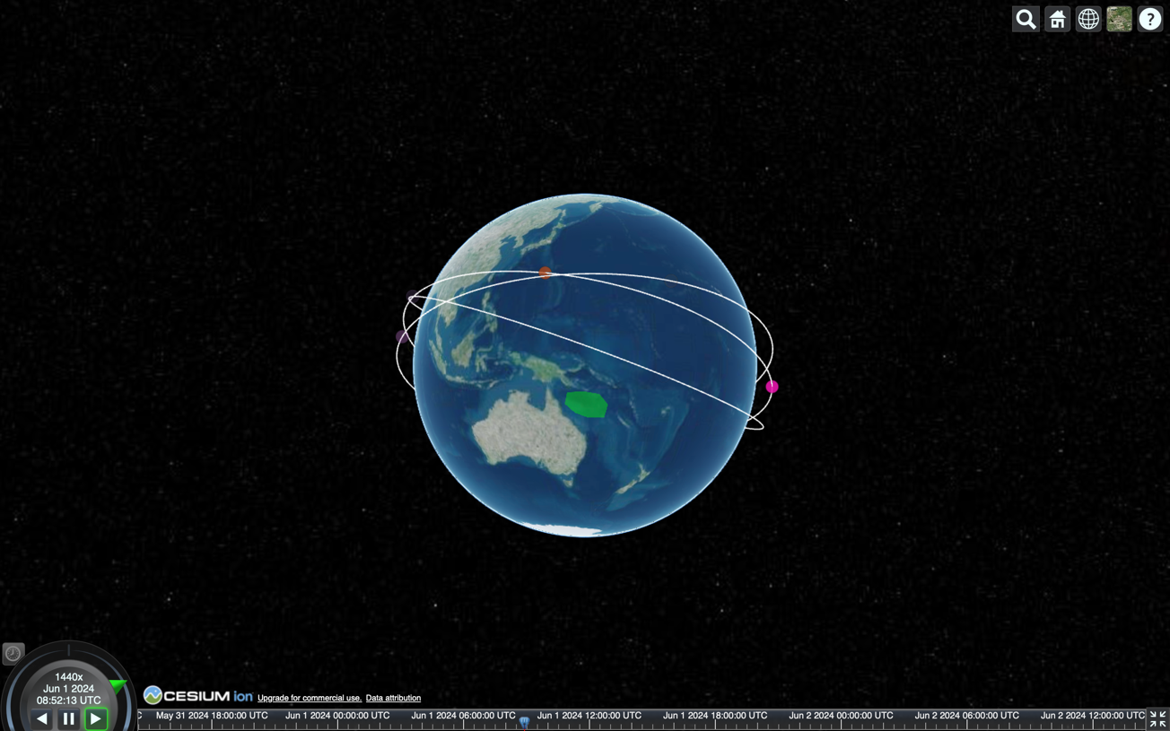

**Fig screenshot of constellation for cum dwell time 14200 sec and revisit time of 38860 sec**

**75006870**

**Test6: NSGA3 optimizer, inclination angles set to be within the range of 20-90.**

**Applying Dynamic Decreasing High Mutation and Increasing Low Crossover**

**(DHM/ILC) concept (**Hassanat et al., 2019)**, which starts with 100% mutation and 0% crossover. Gradually decreases mutation rate and increases crossover rate over generations. At the last generation, mutation is 0% and crossover is 100%.**

**Test parameters:**

|  |  |  |  |  |
| --- | --- | --- | --- | --- |
| **Pop_size (n)** | **nGen** | **Pop_decrease_rate** | **Initial_crossover probability** | **Initial_mutation probability** |
| **50** | **100** | **0%** | **0 $↑$** | **1.0 $↓$** |

**Mathematical expression of DHM/ILC methods,**

**Cxpb = gen/nGen**

**Mxpb = 1 – (gen / nGen)**

**Results outcome:**

**As the pareto Front suggested, final optimal solution of this test is**

**Best fitness solution (i and RAAN) for 3 plane two equally weighted objectives**

|  |  |  |  |
| --- | --- | --- | --- |
| **Inclinations (i)** | **RAANs** | **Min Cum revisit time** | **Max Cum dwell time** |
| **[**  **20.0, 63.320, 20.0**  **]** | **[**  **315.041,**  **260.879,**  **12.137**  **]** | **52630.0** | **10940.0** |

**Test7: NSGA3 optimizer, inclination angles set to be within the range of 20-90.**

**Applying Dynamic Increasing Low Mutation and Decreasing High Crossover**

**(ILM/DHC) concept (**Hassanat et al., 2019)**, which starts with 0% mutation and 100% crossover. Gradually increasing mutation rate and decreasing crossover rate over generations. At the last generation, mutation will be 100% and crossover is 0%.**

**Test parameters:**

|  |  |  |  |  |
| --- | --- | --- | --- | --- |
| **Pop_size (n)** | **nGen** | **Pop_decrease_rate** | **Initial_crossover probability** | **Initial_mutation probability** |
| **50** | **80** | **0%** | **1.0 $↓$** | **0.0 $↑$** |

**Mathematical expression of ILM/DHC methods,**

**Cxpb = 1.0 – (gen/nGen)**

**Mxpb = gen / nGen**

|  |  |  |  |
| --- | --- | --- | --- |
| **Inclinations (i)** | **RAANs** | **Min Cum revisit time** | **Max Cum dwell time** |
| **[**  **66.777,**  **21.06,**  **38.56**  **]** | **[**  **165.153,**  **141.885,**  **296.492]]** | **55420.0** | **7760.0** |

**Test8: Assumption for inclination angle range of (120-170) as per the results of experiment 3 and for higher coverage in Australian region best inclination angle is 141.31 degree {Wijayatunga, 2021 #40}**

**Applying Dynamic Increasing Low Mutation and Decreasing High Crossover**

**(ILM/DHC) concept (**Hassanat et al., 2019)**, which starts with 0% mutation and 100% crossover. Gradually increasing mutation rate and decreasing crossover rate over generations. At the last generation, mutation will be 100% and crossover is 0%.**

**Test parameters:**

|  |  |  |  |  |
| --- | --- | --- | --- | --- |
| **Pop_size (n)** | **nGen** | **Pop_decrease_rate** | **Initial_crossover probability** | **Initial_mutation probability** |
| **50** | **80** | **0%** | **1.0 $↓$** | **0.0 $↑$** |

**Test9: Approaching for inclination angle range of (120-170). Currently running on my laptop**

**NSGA3 optimizer, inclination angles set to be within the range of 120-170.**

**Applying Dynamic (DHM/ILC) concept. In this test, we use less half aperature angle for small swath width of circular field of view, that will gives high resolution. As from earlier test, it can be noticed that, with n of 50, the optimizer nearly comes to its optimum solution earlier around 80-90 generation.**

**Test parameters:**

|  |  |  |  |  |  |
| --- | --- | --- | --- | --- | --- |
| **Pop_size (n)** | **nGen** | **Pop_decrease_rate** | **Initial_crossover probability** | **Initial_mutation probability** | **FOV Half Aperature angle_degree** |
| **50** | **80** | **0%** | **0** | **1.0** | **1.5** |

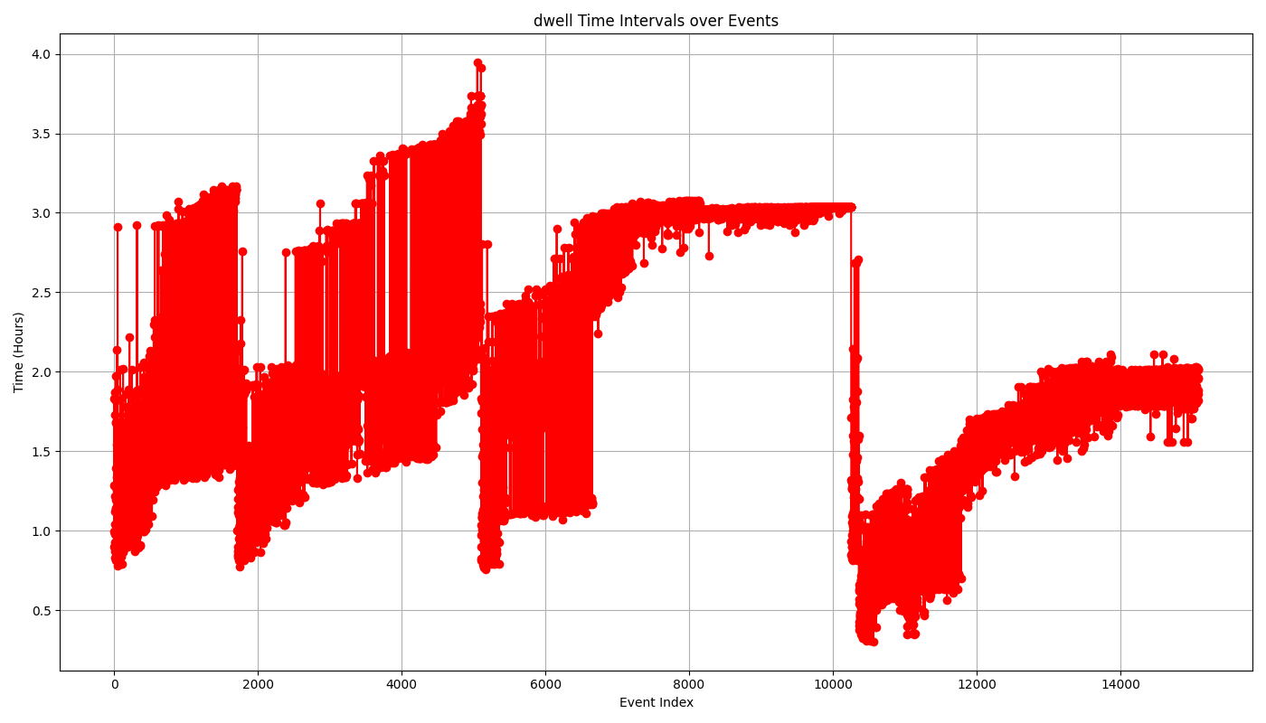

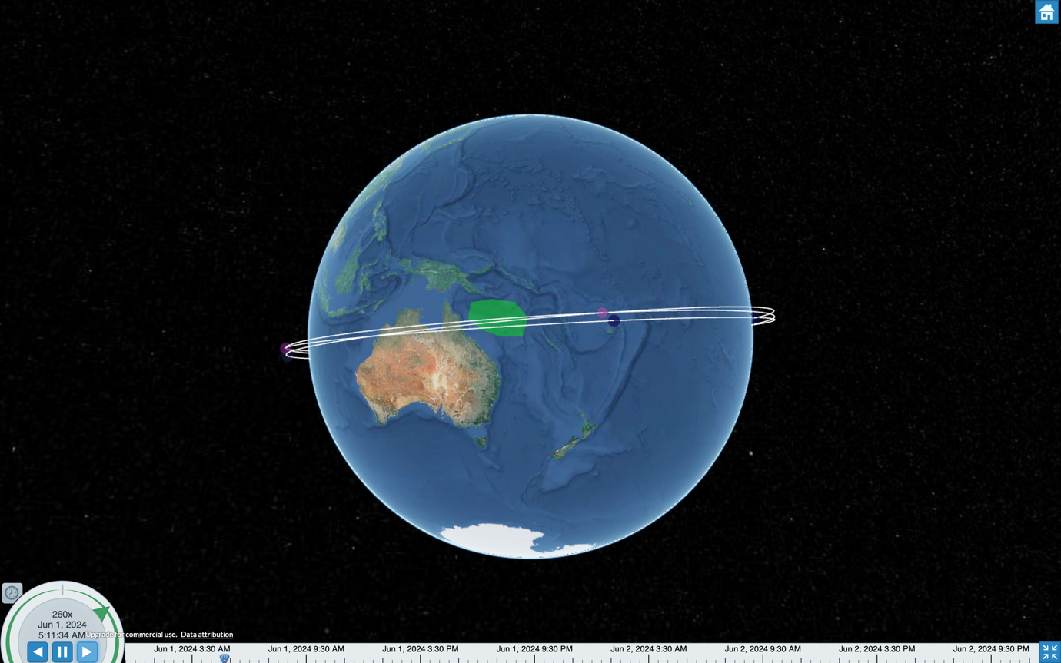

Experiment 7: Referenced to Experiment-6, reduce the satellite number and plane for cost reduction

Number of Plane = 2

Satellite per plane = 4

Narrow down the inclination and raan angle range

i = (140,170)

raan = (45,65)

|  |  |  |  |  |
| --- | --- | --- | --- | --- |
| **Population size (n)** | **# of generation** | **crossover probability** | **mutation probability** | **Sensor FOV Half Aperature angle (degrees)** |
| 50 | 80 | 0 $↑$ | 1.0 $↓$ | 1.5 |

Outcome:

|  |  |  |  |
| --- | --- | --- | --- |
| **Inclinations (i)** | **RAANs** | **Min Cum revisit time** | **Max Cum dwell time** |
| 163.92, 163.79 | 49.81, 55.81 | 21720 (6.03 hours) | 4860(1.35 hours) |

**Future studies:**

Further studies includes the research and experiment over Earth's gravity field, measurements such as the geoid, gravity anomalies, deflections, and dynamic Doppler effect.

[1] A. Hassanat, K. Almohammadi, E. a. Alkafaween, E. Abunawas, A. Hammouri, and V. S. Prasath, "Choosing mutation and crossover ratios for genetic algorithms—a review with a new dynamic approach," *Information,* vol. 10, no. 12, p. 390, 2019.

[2] U. S. D. M. Agency, *Department of Defense World Geodetic System 1984: its definition and relationships with local geodetic systems*. Defense Mapping Agency, 1987.

Matar, J., Rodriguez-Cassola, M., Krieger, G. and Moreira, A., 2023. On the Equivalence of LEO-SAR Constellations and Complex High-Orbit SAR Systems for the Monitoring of Large-Scale Processes. *IEEE Geoscience and Remote Sensing Letters*.